Civil war in Georgia

UNSC Resolution: | 1393
Date of adoption: | 01/31/02
Operative paragraph: | 6
Demand number: | 1393.0611

David Siroky

Wording of demand

receive the "Basic Principles for the Distribution of Competencies between Tbilisi and Sukhumi" and its transmittal letter [see op. 3 in current resolution] in the near future, give them full and open consideration, and engage into constructive negotiations on their substance without delay thereafter

List of addressees of the demand

Government of Georgia, Abkhazia

Short-term compliance

Description of the addressee(s)’ conduct

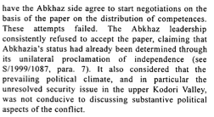

S/2002/469

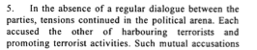

S/2002/469

Assessment

Short-term compliance
No or marginal compliance (1) | Medium low compliance (2) | Medium high compliance (3) | Full or almost full compliance (4)

Considerations underlying the assessment

Medium-term compliance

Description of the addressee(s)’ conduct

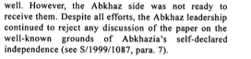

S/2002/742

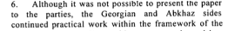

S/2002/742

Assessment

Medium-term compliance
No or marginal compliance (1) | Medium low compliance (2) | Medium high compliance (3) | Full or almost full compliance (4)

Considerations underlying the assessment

Depth of demand

Assessment

Level of depth of demand
Low depth of demand (1) | Medium depth of demand (2) | High depth of demand (3)

Considerations underlying the assessment

Level of confidence about coding decisions

Level of confidence about coding decision
Extremely high | High | Moderate

Comments to IPI (if any)

Civil war in Georgia

UNSC Resolution: | 1393
Date of adoption: | 01/31/02
Operative paragraph: | 7
Demand number: | 1393.0711

David Siroky

Wording of demand

spare no efforts to overcome ongoing mutual mistrust of the other party

List of addressees of the demand

Government of Georgia, Abkhazia

Short-term compliance

Description of the addressee(s)’ conduct

S/2002/469

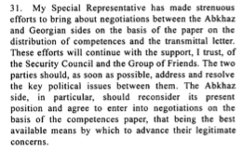

S/2002/469

Assessment

Short-term compliance
No or marginal compliance (1) | Medium low compliance (2) | Medium high compliance (3) | Full or almost full compliance (4)

Considerations underlying the assessment

Medium-term compliance

Description of the addressee(s)’ conduct

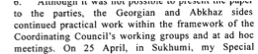

S/2002/742

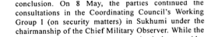

S/2002/742

Assessment

Medium-term compliance
No or marginal compliance (1) | Medium low compliance (2) | Medium high compliance (3) | Full or almost full compliance (4)

Considerations underlying the assessment

Depth of demand

Assessment

Level of depth of demand
Low depth of demand (1) | Medium depth of demand (2) | High depth of demand (3)

Considerations underlying the assessment

Level of confidence about coding decisions

Level of confidence about coding decision
Extremely high | High | Moderate

Comments to IPI (if any)

Civil war in Georgia

UNSC Resolution: | 1393
Date of adoption: | 01/31/02
Operative paragraph: | 8
Demand number: | 1393.0811

David Siroky

Wording of demand

cease violations of the Moscow Agreement (S/1994/583, annex I) immediately

List of addressees of the demand

Government of Georgia, Abkhazia

Short-term compliance

Description of the addressee(s)’ conduct

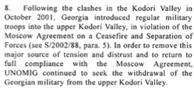

S/2002/469

Assessment

Short-term compliance
No or marginal compliance (1) | Medium low compliance (2) | Medium high compliance (3) | Full or almost full compliance (4)

Considerations underlying the assessment

Medium-term compliance

Description of the addressee(s)’ conduct

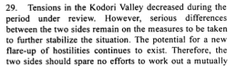

S/2002/742

Assessment

Medium-term compliance
No or marginal compliance (1) | Medium low compliance (2) | Medium high compliance (3) | Full or almost full compliance (4)

Considerations underlying the assessment

Depth of demand

Assessment

Level of depth of demand
Low depth of demand (1) | Medium depth of demand (2) | High depth of demand (3)

Considerations underlying the assessment

Level of confidence about coding decisions

Level of confidence about coding decision
Extremely high | High | Moderate

Comments to IPI (if any)

Civil war in Georgia

UNSC Resolution: | 1393
Date of adoption: | 01/31/02
Operative paragraph: | 9
Demand number: | 1393.0911

David Siroky

Wording of demand

implement fully and expeditiously the protocol signed by both parties on 17 January 2002 regarding the situation in the Kodori valley (in particular by the Georgian side), observe security agreements and have political leaders publicly dissociate themselves from militant rhetoric and demonstrations of support for military options and for the activities of illegal armed groups

List of addressees of the demand

Government of Georgia, Abkhazia

Short-term compliance

Description of the addressee(s)’ conduct

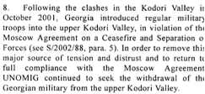

S/2002/469

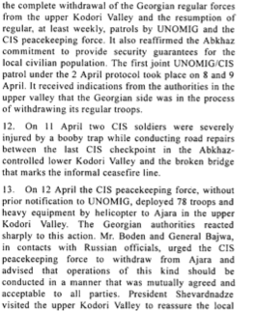

S/2002/469

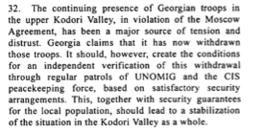

S/2002/469

Assessment

Short-term compliance
No or marginal compliance (1) | Medium low compliance (2) | Medium high compliance (3) | Full or almost full compliance (4)

Considerations underlying the assessment

Medium-term compliance

Description of the addressee(s)’ conduct

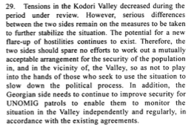

S/2002/742

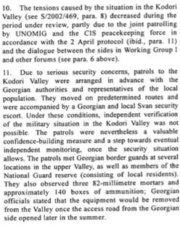
S/2002/742

Assessment

Medium-term compliance
No or marginal compliance (1) | Medium low compliance (2) | Medium high compliance (3) | Full or almost full compliance (4)

Considerations underlying the assessment

Depth of demand

Assessment

Level of depth of demand
Low depth of demand (1) | Medium depth of demand (2) | High depth of demand (3)

Considerations underlying the assessment

Level of confidence about coding decisions

Level of confidence about coding decision
Extremely high | High | Moderate

Comments to IPI (if any)

Civil war in Georgia

UNSC Resolution: | 1393
Date of adoption: | 01/31/02
Operative paragraph: | 9
Demand number: | 1393.0912

David Siroky

Wording of demand

honor undertaking in the protocol signed on 17 January 2002 regarding the situation in the Kodori Valley not to take advantage of the withdrawal of Georgian troops

List of addressees of the demand

Government of Georgia, Abkhazia

Short-term compliance

Description of the addressee(s)’ conduct

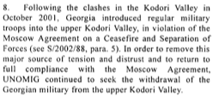

S/2002/469

Assessment

Short-term compliance
No or marginal compliance (1) | Medium low compliance (2) | Medium high compliance (3) | Full or almost full compliance (4)

Considerations underlying the assessment

Medium-term compliance

Description of the addressee(s)’ conduct

S/2002/742

Assessment

Medium-term compliance
No or marginal compliance (1) | Medium low compliance (2) | Medium high compliance (3) | Full or almost full compliance (4)

Considerations underlying the assessment

Depth of demand

Assessment

Level of depth of demand
Low depth of demand (1) | Medium depth of demand (2) | High depth of demand (3)

Considerations underlying the assessment

Level of confidence about coding decisions

Level of confidence about coding decision
Extremely high | High | Moderate

Comments to IPI (if any)

Civil war in Georgia

UNSC Resolution: | 1393
Date of adoption: | 01/31/02
Operative paragraph: | 10
Demand number: | 1393.1011

David Siroky

Wording of demand

ensure the necessary revitalization of the peace process in all its major aspects, to resume work in the Coordinating council and its relevant mechanisms, to build on the results of the Yalta meeting on confidence-building measures, and to implement the proposals agreed on that occasion in a purposeful and cooperative manner

List of addressees of the demand

Government of Georgia, Abkhazia

Short-term compliance

Description of the addressee(s)’ conduct

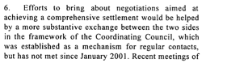

S/2002/469

Assessment

Short-term compliance
No or marginal compliance (1) | Medium low compliance (2) | Medium high compliance (3) | Full or almost full compliance (4)

Considerations underlying the assessment

Medium-term compliance

Description of the addressee(s)’ conduct

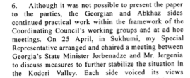

S/2002/742

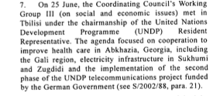

S/2002/742

Assessment

Medium-term compliance
No or marginal compliance (1) | Medium low compliance (2) | Medium high compliance (3) | Full or almost full compliance (4)

Considerations underlying the assessment

Depth of demand

Assessment

Level of depth of demand
Low depth of demand (1) | Medium depth of demand (2) | High depth of demand (3)

Considerations underlying the assessment

Level of confidence about coding decisions

Level of confidence about coding decision
Extremely high | High | Moderate

Comments to IPI (if any)

Civil war in Georgia

UNSC Resolution: | 1393
Date of adoption: | 01/31/02
Operative paragraph: | 12
Demand number: | 1393.1211

David Siroky

Wording of demand

implement the recommendations of the joint assessment mission to the Gali district, carried out under the aegis of the UN

List of addressees of the demand

Government of Georgia, Abkhazia

Short-term compliance

Description of the addressee(s)’ conduct

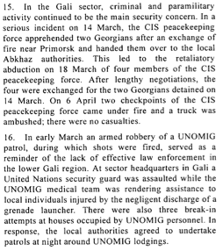

S/2002/469

Assessment

Short-term compliance
No or marginal compliance (1) | Medium low compliance (2) | Medium high compliance (3) | Full or almost full compliance (4)

Considerations underlying the assessment

Medium-term compliance

Description of the addressee(s)’ conduct

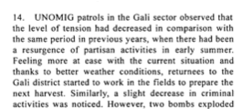

S/2002/742

Assessment

Medium-term compliance
No or marginal compliance (1) | Medium low compliance (2) | Medium high compliance (3) | Full or almost full compliance (4)

Considerations underlying the assessment

Depth of demand

Assessment

Level of depth of demand
Low depth of demand (1) | Medium depth of demand (2) | High depth of demand (3)

Considerations underlying the assessment

Level of confidence about coding decisions

Level of confidence about coding decision
Extremely high | High | Moderate

Comments to IPI (if any)

Civil war in Georgia

UNSC Resolution: | 1393
Date of adoption: | 01/31/02
Operative paragraph: | 12
Demand number: | 1393.1212

David Siroky

Wording of demand

improve law enforcement involving the local population and address the lack of instruction in Georgian of the local Georgian population

List of addressees of the demand

Government of Georgia, Abkhazia

Short-term compliance

Description of the addressee(s)’ conduct

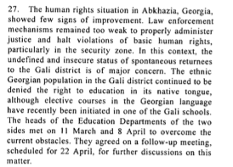

S/2002/469

Assessment

Short-term compliance
No or marginal compliance (1) | Medium low compliance (2) | Medium high compliance (3) | Full or almost full compliance (4)

Considerations underlying the assessment

Medium-term compliance

Description of the addressee(s)’ conduct

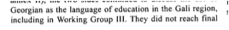

S/2002/742

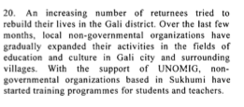

S/2002/742

Assessment

Medium-term compliance
No or marginal compliance (1) | Medium low compliance (2) | Medium high compliance (3) | Full or almost full compliance (4)

Considerations underlying the assessment

Depth of demand

Assessment

Level of depth of demand
Low depth of demand (1) | Medium depth of demand (2) | High depth of demand (3)

Considerations underlying the assessment

Level of confidence about coding decisions

Level of confidence about coding decision
Extremely high | High | Moderate

Comments to IPI (if any)

Civil war in Georgia

UNSC Resolution: | 1393
Date of adoption: | 01/31/02
Operative paragraph: | 14
Demand number: | 1393.1411

David Siroky

Wording of demand

take all necessary steps to identify those responsible for the shooting down of a UNOMIG helicopter on 8 October 2001 and bring them to justice as well as provide appropriate security and ensure the freedom of movement of UNOMIG, the CIS peacekeeping force and other international personnel

List of addressees of the demand

Government of Georgia, Abkhazia

Short-term compliance

Description of the addressee(s)’ conduct

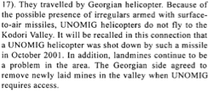

S/2002/469

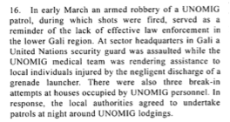
S/2002/469

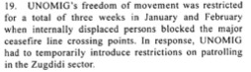

S/2002/469

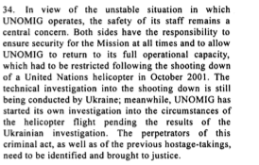

S/2002/469

Assessment

Short-term compliance
No or marginal compliance (1) | Medium low compliance (2) | Medium high compliance (3) | Full or almost full compliance (4)

Considerations underlying the assessment

Medium-term compliance

Description of the addressee(s)’ conduct

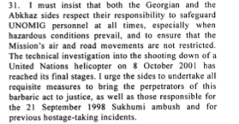

S/2002/742

Assessment

Medium-term compliance
No or marginal compliance (1) | Medium low compliance (2) | Medium high compliance (3) | Full or almost full compliance (4)

Considerations underlying the assessment

Depth of demand

Assessment

Level of depth of demand
Low depth of demand (1) | Medium depth of demand (2) | High depth of demand (3)

Considerations underlying the assessment

Level of confidence about coding decisions

Level of confidence about coding decision
Extremely high | High | Moderate

Comments to IPI (if any)

Civil war in Georgia

UNSC Resolution: | 1393
Date of adoption: | 01/31/02
Operative paragraph: | 15
Demand number: | 1393.1511

David Siroky

Wording of demand

uphold commitment to put an end to the activities of illegal armed groups crossing into Abkhazia, Georgia, from the Georgian-controlled side of the ceasefire line

List of addressees of the demand

Government of Georgia, Abkhazia

Short-term compliance

Description of the addressee(s)’ conduct

S/2002/469

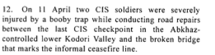

S/2002/469

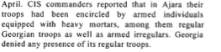

S/2002/469

S/2002/469

Assessment

Short-term compliance
No or marginal compliance (1) | Medium low compliance (2) | Medium high compliance (3) | Full or almost full compliance (4)

Considerations underlying the assessment

Medium-term compliance

Description of the addressee(s)’ conduct

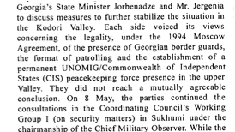

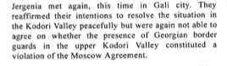

S/2002/742

Assessment

Medium-term compliance
No or marginal compliance (1) | Medium low compliance (2) | Medium high compliance (3) | Full or almost full compliance (4)

Considerations underlying the assessment

Depth of demand

Assessment

Level of depth of demand
Low depth of demand (1) | Medium depth of demand (2) | High depth of demand (3)

Considerations underlying the assessment

Level of confidence about coding decisions

Level of confidence about coding decision
Extremely high | High | Moderate

Comments to IPI (if any)

